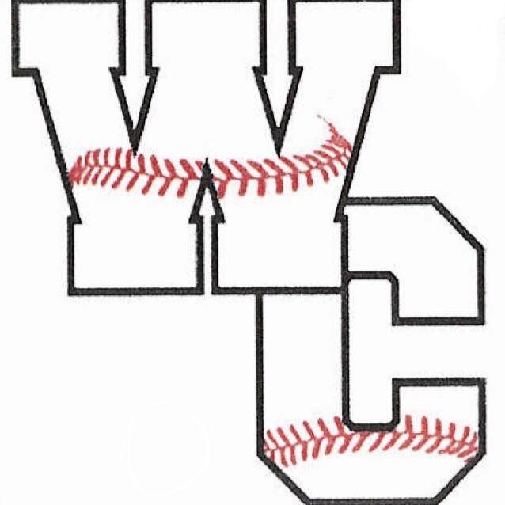**Westmoreland County** Little League

***The youth of today, the leaders of tomorrow.***

To Our Sponsors,

That time of year is upon us once again! The children are dusting off their gloves, rounding the brims of their new caps and practicing their swings in the backyards with Mom and Dad. Opening day is around the corner and our teams are anxious to get the season started. None of this is possible, however, without you - our valued sponsors.

All of you have been more than gracious in the past, and we hope you will continue your support of Little League this year and in the years to come. As Westmoreland County Little League continues to grow, the children and volunteers need the continued support of our community. For the 2022-2023 season, we will be continuing different levels of sponsorship and each level comes with its own form of recognition and/or advertisement.

Below you will see various levels of sponsorship that are available this year for the league.

**Extra Grand Slam – $600.00 Donation**

With your $600.00 donation, you will sponsor a whole team within the Little League that will have the name of

your business printed on the back of each player’s jersey, (2) full-color 3 ft. x 5 ft. advertising banners located at

two fields of your choice (Hurt Field in Montross, Hamblin Field in Oak Grove, or Westmoreland Recreation Park,

Montross) during the entire Little League season, an engraved Sponsors Plaque from Westmoreland County Little

League with a picture of the team you have sponsored. In addition, for our Fall Ball season the name of your

business will be printed on the back of each player’s jersey. The banners will also be left up for advertisement.

The sponsors for this level of sponsorship are limited to 6 sponsors as we only have a small number of teams in

the fall.

**Grand Slam – $500.00 Donation**

With your $500.00 donation, you will sponsor a whole team within the Little League that will have the name of your

business printed on the back of each player’s jersey, (2) full-color 3 ft. x 5 ft. advertising banners located at two

fields of your choice (Hurt Field in Montross, Hamblin Field in Oak Grove, or Westmoreland Recreation Park,

Montross) during the entire Little League season, an engraved Sponsors Plaque from Westmoreland County Little

League with a picture of the team you have sponsored.

# Home Run - $300.00 Donation

With your $300.00 donation, you will receive (1) full-color 3 ft. x 5 ft. advertising banner located at one field of choice

of three fields (Hurt Field in Montross, Hamblin Field in Oak Grove, or Westmoreland Recreation Park) during the

entire Little League season. You will receive an engraved Sponsors Plaque from Westmoreland County Little

League with a picture of a team. You can choose the specific team you would like a picture of or the league will

select one.

**Triple - $200.00 Donation**

Sponsors will receive (1) full-color 3 ft x 5 ft advertising banner located at one field of choice of three fields (Hurt

Field in Montross, Hamblin Field in Oak Grove, or Westmoreland Recreation Park) during the entire Little League

season and will receive a standard 6x8 Sponsors Plaque from Westmoreland County Little League.

**Double - $100.00 Donation**

Sponsors will receive a standard 5x7 Sponsors Plaque.

# Single - $75.00 Donation

For the single sponsorship, your donation will go to “**Sponsor-A-Player”.** This is a level that was created to allow

sponsors the opportunity to sponsor a player who otherwise may not be able to play due to the financial burden for

their family. The sponsor can select who they would like to sponsor or the league will apply the funds to a player

in need. Sponsor will receive a certificate of appreciation from Westmoreland County Little League.

We hope you will find a level of sponsorship that best fits your budget and your heart, and please know that we greatly appreciate any and all donations that are given to the League no matter how large or small. Every bit helps so reach as deeply as you can and support the children of your county as they learn the values taught to them in Little League baseball and softball.

Sincerely,

Westmoreland County Little League

**Westmoreland County Little League**

**2022-2023 Sponsorship Agreement**

Name of Sponsor: ___________________________________________________________

Name of Sponsor Representative: _______________________________________________

Mailing Address: _____________________________________________________________

City: ______________________ St: __________ Zip: __________

Phone Number: _____________________

Email Address: ___________________________

Amount enclosed: $__________ (make checks payable to Westmoreland Co. Little League)

Level of Sponsorship: __________________________________________

If you selected Extra Grand Slam or Grand Slam please indicate the Name you would like printed on Jerseys: _______________________________________________________________________________

**IMPORTANT: All Extra Grand Slam, Grand Slam, Home Run, and Triple Sponsorships must be accompanied by a business card, letterhead or other artwork. Artwork may also be submitted by EPS file to westmorelandcountylittleleague@gmail.com. Artwork may be color or black & white and must be designed as you wish it to appear on your banner. All renewals are subject to approval by Westmoreland County Little League.**

This agreement between the Westmoreland County Little League (hereafter referred to as “the League”) and the above signed Sponsor is for the 2022-2023 season. Sponsorship of a team in the League must be, for the Sponsor, out of a sense of duty to help the community. While Sponsorship does afford some benefits (detailed below), the higher purpose is to help the Local Little League impart the values of teamwork, sportsmanship, and fair play to the children of the community, so that they may someday use these values in becoming good citizens.

Sponsorship of a team in the League does not permit the Sponsor to have any rights or responsibilities in the operation of

the League or any team in the League, nor does the Sponsor have any rights or responsibilities in the selection of managers, coaches or players for any team in the League. Nothing herein shall make us partners or joint ventures. The Sponsor and the League are independent contractors with respect to one another, and neither shall have any authority to represent or bind the other in any manner or to any extent whatsoever, except as specified herein.

The Sponsor shall have the right to use the following term in advertisements, posters, brochures, newsletters, etc.: “Sponsor of a team in the Westmoreland County Little League.” Sponsorship does NOT give the Sponsor the right to use the word “official” in connection with its Sponsorship. Any reference to the Sponsorship under this agreement must make it clear that the Sponsorship is with a team or teams in the League only, and NOT for Little League Baseball. Use of the “keystone logo” or any other logo of Little League Baseball is prohibited unless permission is expressly granted in writing by Little League Baseball International.

Westmoreland County Little League is a 501(C)(3) Non-profit Charitable Organization. Accepted and agreed to:

|  |  |
| --- | --- |
| __________________________________________________ Sponsor Representative Signature  __________________________________________________ Sponsorship Coordinator Signature | _____________________________ Date  _____________________________ Date |

Please mail all donations and completed forms to:

**Westmoreland County Little League**

**P. O. Box 116**

**Montross, VA 22520**